**Zeal education**

**manager**



**TABLE OF FIGURE**

**Figure 1 3**

**Figure 2 4**

**Figure 3 5**

**Figure 4 6**

**Figure 5 7**

**Figure 6 8**

**Figure 7 9**

**Figure 8 10**

**Figure 9 11**

**HOME PAGE**



**FIGURE 1**

**ABOUT US**

******Figure 2**

**COURSES**

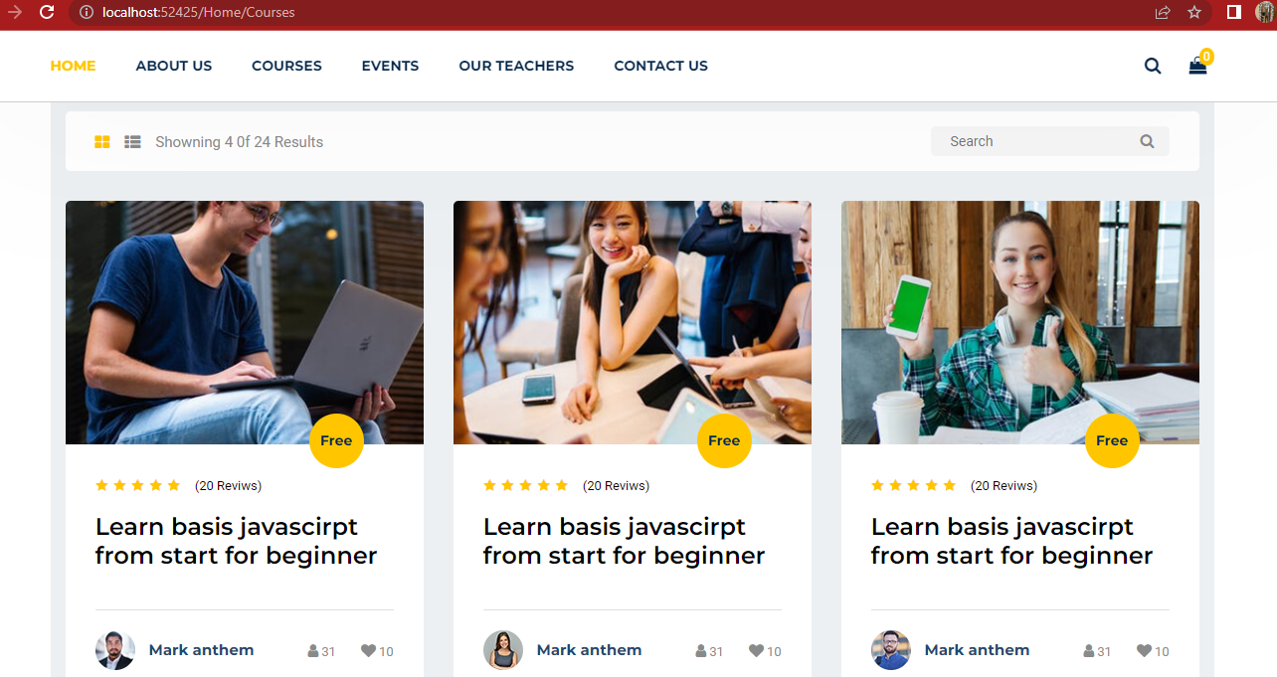

**Figure 3**

**CONTACT US PAGE**

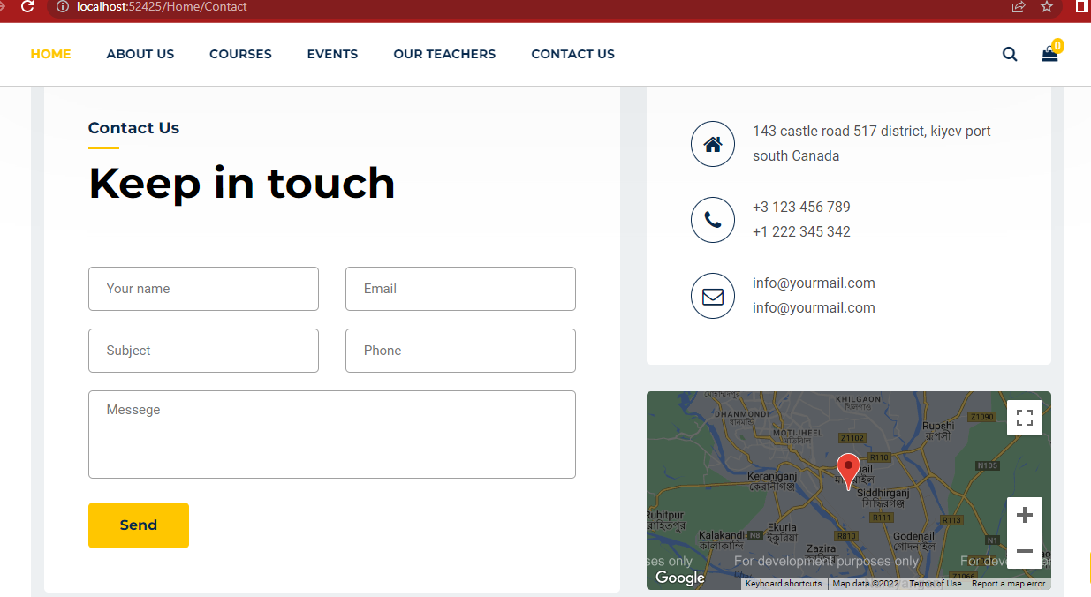

**Figure 4**

**EVENTS**

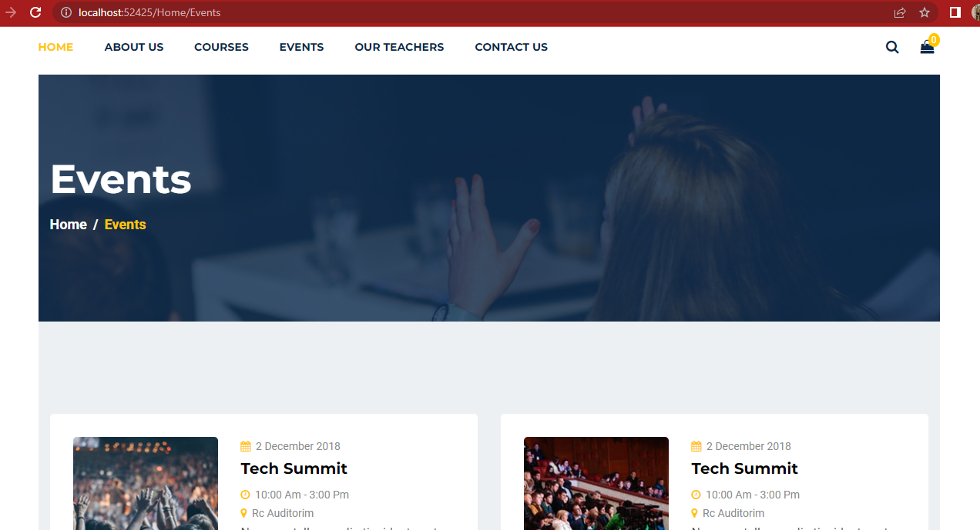

**Figure 5**

**LOGIN PAGE**

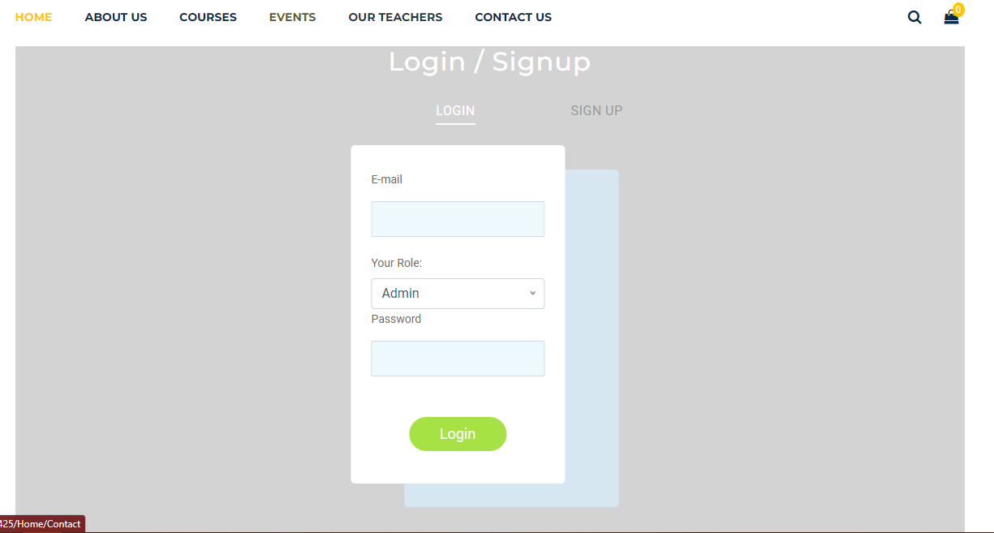

**Figure 6**

**REGISTER PAGE**

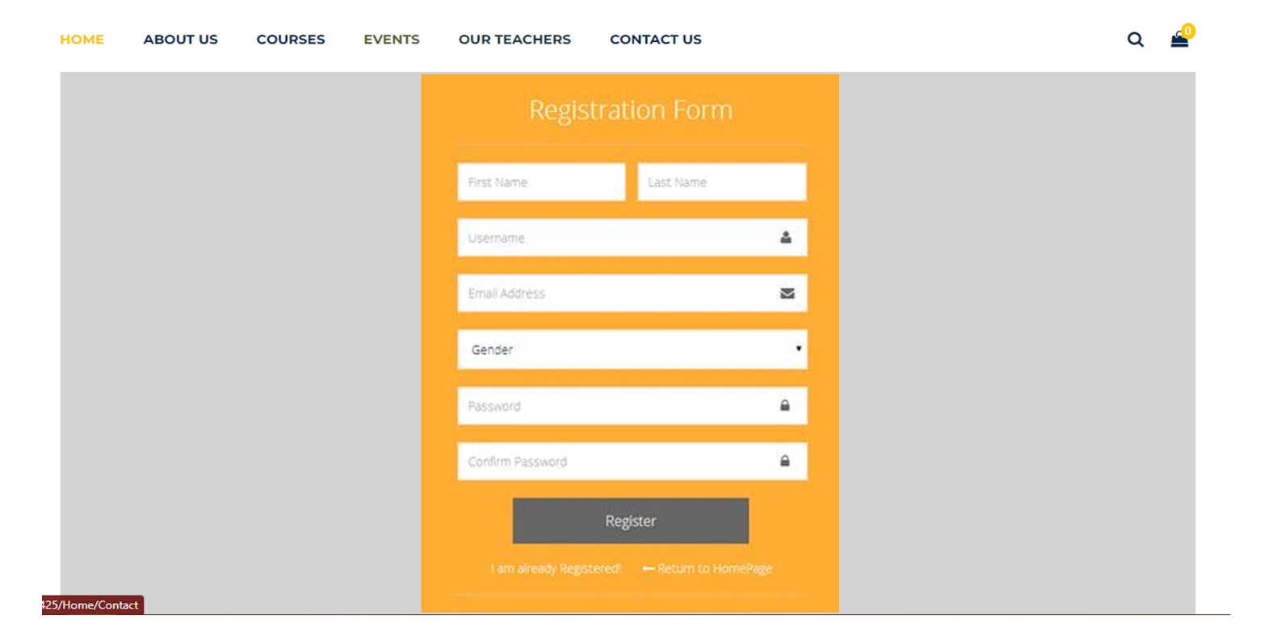

**Figure 7**

**HEADER & FOOTER**



**Figure 8**



**Figure 9**